**Link:** [**https://www.kaggle.com/datasets/desalegngeb/students-exam-scores**](https://www.kaggle.com/datasets/desalegngeb/students-exam-scores)

**Students Exam Scores: Extended Dataset**

Exam scores for students at a public school

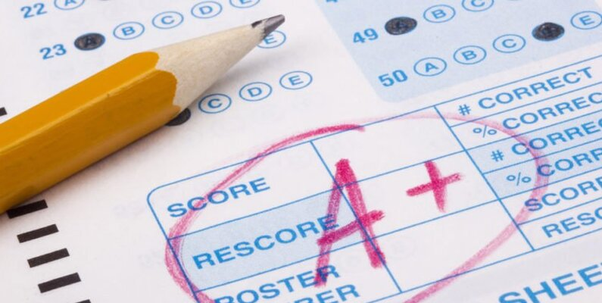

**Students Exam Scores: Extended Dataset**

arrow_drop_up365

**New Notebook**

file_download**Download (711 kB)**arrow_drop_down



more_vert

Data Card

Code (62)

Discussion (4)

Suggestions (0)

**About Dataset**

This dataset includes scores from three test scores of students at a (fictional) public school and a variety of personal and socio-economic factors that may have interaction effects upon them.

**Remark/warning/disclaimer:**

* This datasets are **fictional** and should be used for **educational purposes only**.
* The original dataset generator creator is Mr. [Royce Kimmons](http://roycekimmons.com/tools/generated_data/exams)
* There are *similar datasets* on kaggle already but this one is **different** and **arguably better** in two ways.  
  -> 1) has **more data** (**>30k** instead of just the 1k the other datasets have),  
  -> 2) has extended datasets with **more features** (15 instead of 9) and has **missing values** which makes it ideal for data cleaning and data preprocessing.

**Data Dictionary (column description)**

1. **Gender**: Gender of the student (male/female)
2. **EthnicGroup**: Ethnic group of the student (group A to E)
3. **ParentEduc**: Parent(s) education background (from some_highschool to master's degree)
4. **LunchType**: School lunch type (standard or free/reduced)
5. **TestPrep**: Test preparation course followed (completed or none)
6. **ParentMaritalStatus**: Parent(s) marital status (married/single/widowed/divorced)
7. **PracticeSport**: How often the student parctice sport (never/sometimes/regularly))
8. **IsFirstChild**: If the child is first child in the family or not (yes/no)
9. **NrSiblings**: Number of siblings the student has (0 to 7)
10. **TransportMeans**: Means of transport to school (schoolbus/private)
11. **WklyStudyHours**: Weekly self-study hours(less that 5hrs; between 5 and 10hrs; more than 10hrs)
12. **MathScore**: math test score(0-100)
13. **ReadingScore**: reading test score(0-100)
14. **WritingScore**: writing test score(0-100)

**Analytics questions:**

1. What factors (features) affect test scores most?
2. Are there interacting features which affect test scores?